SQL Hands on Question
Answers Day- 04

Table Creation
Customers Table
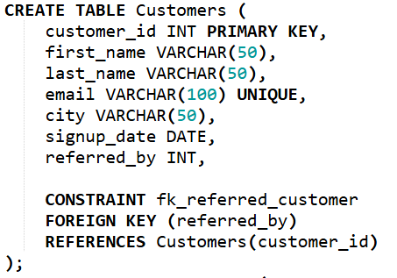
2. Restaurants Table
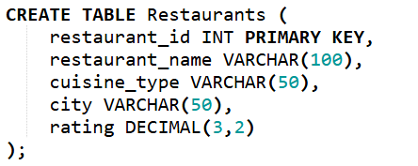
3. Orders Table
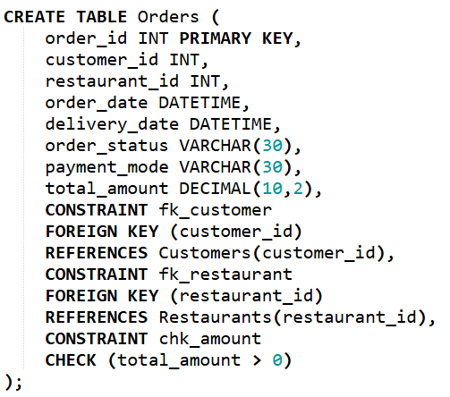
4. Delivery_Partners Table
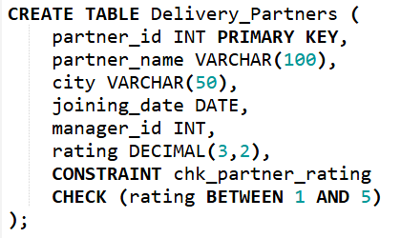
Insert Sample Data
Customers
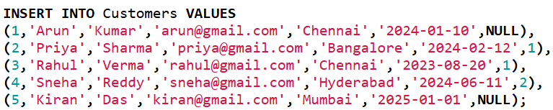
Restaurants
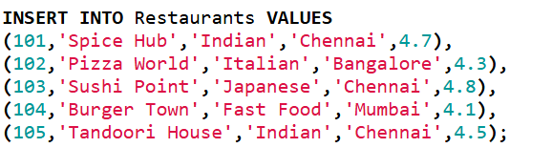
Orders
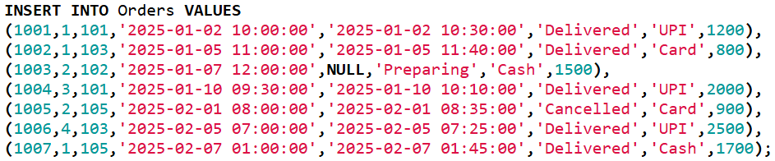
Delivery Partners
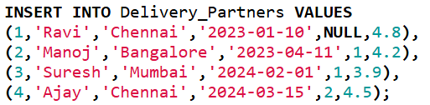

SQL Queries

1. Display all restaurants from Chennai ordered by highest rating
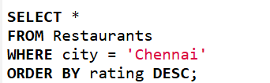
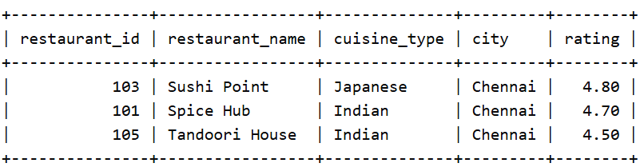

2. Find all orders placed after Jan 1, 2025, amount > 1000 and status not Cancelled
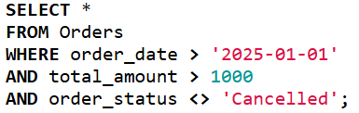
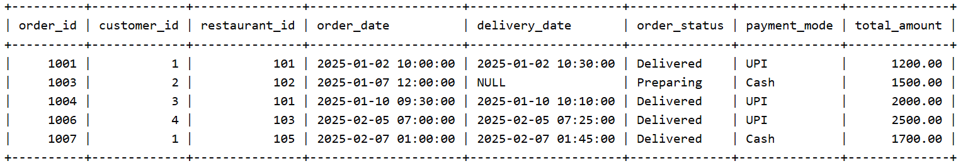

3. Find customers who never placed any order
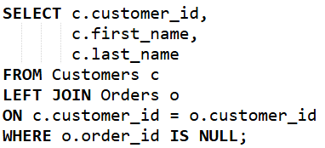
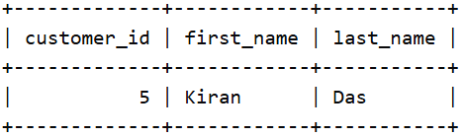

4. In the table some delivery_date values are NULL. Display order_id, delivery status. If delivery date is NULL show it as “Pending Delivery”
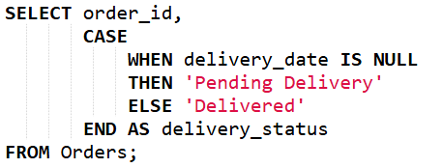
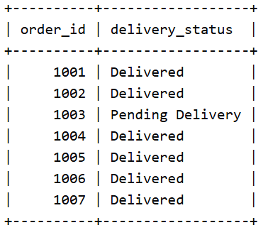

5. The marketing team wants customers who: signed up in 2024, placed more than 5 orders, spent more than 15,000
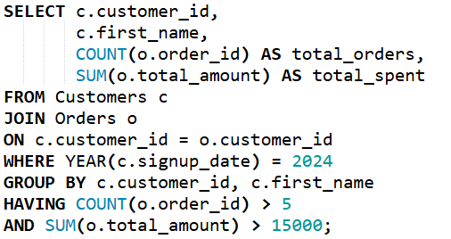

6. Find customers whose order amount is greater than their own average order value.
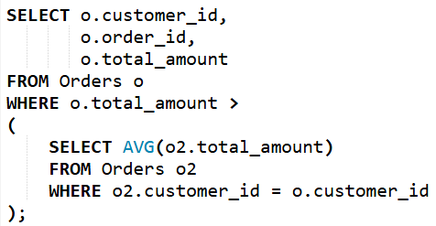
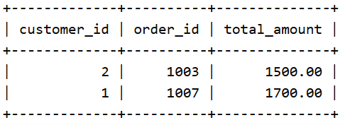

7. Display latest order for each customer
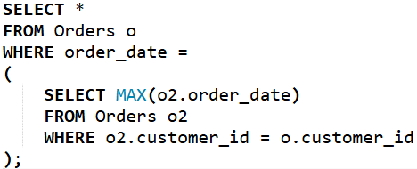
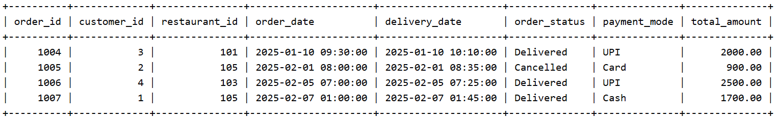

8. Compare a customer’s current order amount with previous order amount and show the difference in the amount
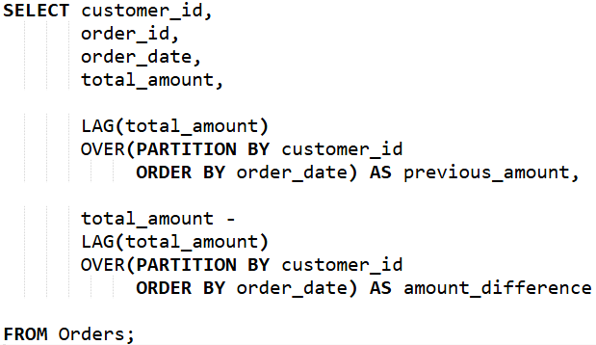
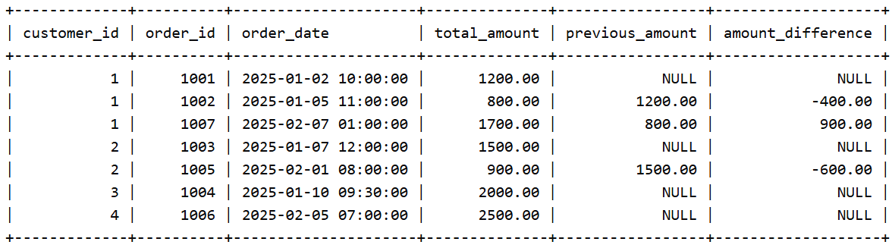

9. Write SQL statements to add: PRIMARY KEY, FOREIGN KEY, UNIQUE constraint, CHECK constraint
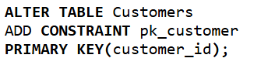
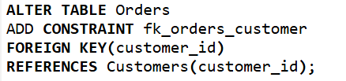
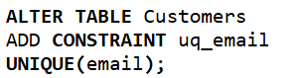
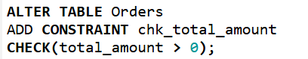

10. Use a CTE to find top 5 customers based on spending.
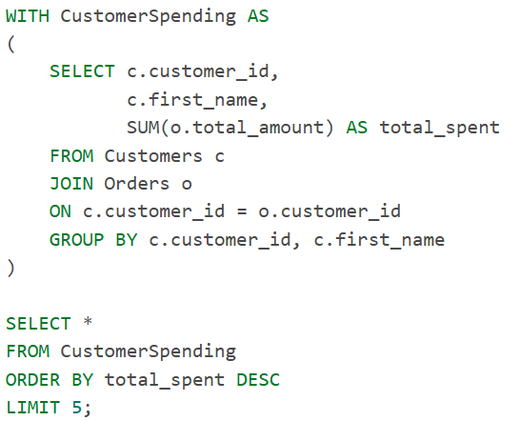
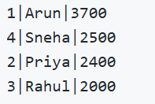

11. Find the number of days between consecutive orders for each customer.
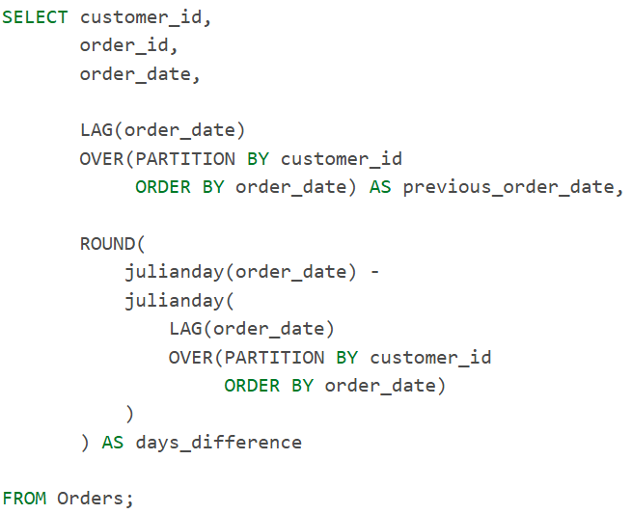
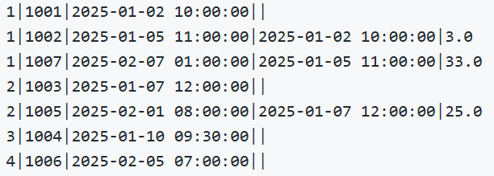

12. Find the hour during which each restaurant receives maximum orders.
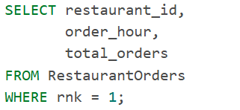
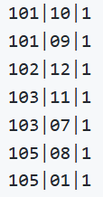

13. Find the highest revenue-generating restaurant each month.
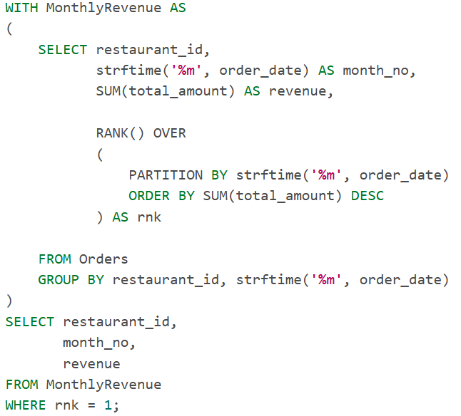
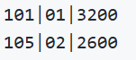

14. Create a report showing: partner_name , total deliveries, avg delivery time , rank within city , performance category Performance Rules: Avg delivery < 20 mins → Excellent 20–40 mins → Good 40 mins → Poor
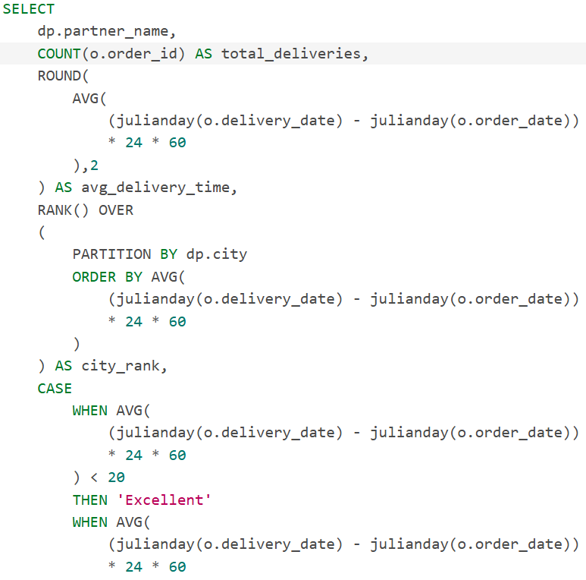
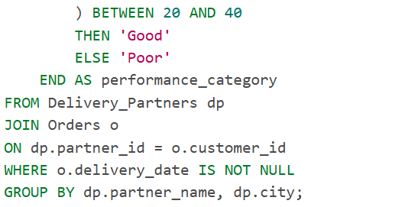
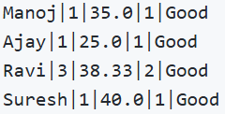

15. Find what percentage of total company revenue each restaurant contributes. Return restaurant_name, total_revenue, contribution_percentage
